Kol Simcha Torah Gazette
For parshas mishpatim 5786
Vol 10 Issue 19 (Whole #485) 27 Shevat 5786/ February 14, 2025
Printed L’illuy nishmas Nechama bas R’ Noach, a”h
For a free subscription, please forward your request to keren18@juno.com
Past emails can be found on the website ShabbosStories.com under Brooklyn Torah Gazette

From Nazi Germany
to the LAPD
By Debbie Paneth

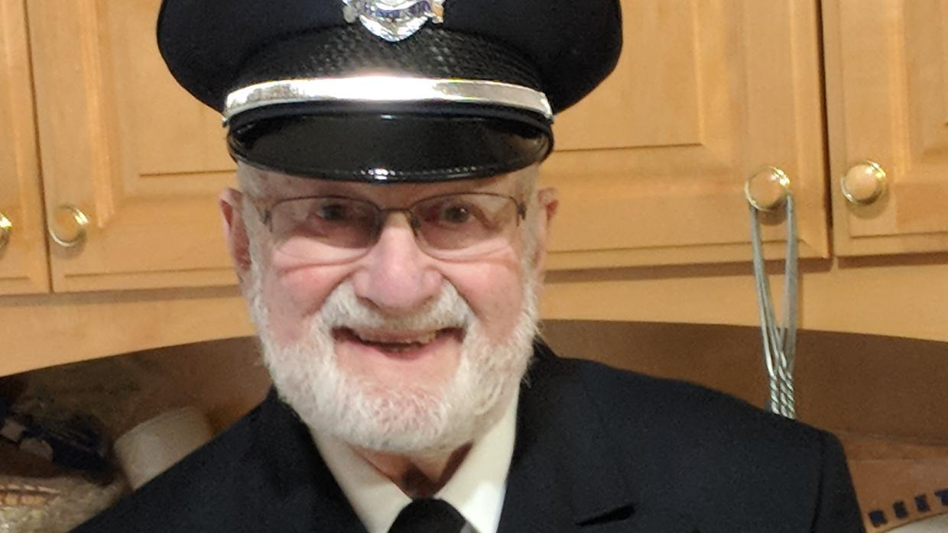
Rabbi Israel Hirsch’s life shows how memory, faith, and integrity can be transformed into lifelong service.

On a cold night in November 1938, in Hamburg, five-year-old Israel Hirsch stood across the street and watched his world burn. Flames consumed the synagogue where his father prayed, worked, and sang. Fire trucks came, lights flashing, sirens wailing, and then did nothing. They had been ordered not to intervene. That was the night Germany stopped being home.
The synagogue was the heart of the neighborhood. Its dome dominated the street, its doors opening daily to prayer, music, and community. Israel’s father, David Hirsch, was its cantor and executive director. Their apartment stood directly across from it. After Kristallnacht, nothing on that street felt familiar again.
Before the flames, the Gestapo came for his father. David Hirsch had been warned and fled, hoping absence might spare his family. It did not. The message was simple and brutal: return or his family would be taken. He came back.
He was forced to open the synagogue safes as sacred objects and communal treasures were emptied before him. Then he was made to watch as the building was set on fire. The fire brigade stood by. Neighbors watched in silence. No one intervened.
When the synagogue collapsed into ash, something else collapsed with it—the belief that this was a country where Jews could still belong.

Miracle of Escape
David Hirsch was arrested that night and deported to Sachsenhausen. There, Jewish men rounded up during Kristallnacht were beaten, starved, and humiliated. Six weeks later, he was unexpectedly released, saved only by a visa to the United States. As he left the camp, a guard called after him: “When we reach the shores of America, we will destroy every last one of you. Now raus, Jude.”
He came home on the first night of Hanukkah, a miracle born in darkness.
Escape came in fragments. In 1939, the family fled Germany for England, carrying little more than hope and uncertainty. Two years later, Israel’s father left for the United States alone, determined to secure a future for his family. For more than two years after that, Israel, his mother, older brother, sister, and his younger brother waited in wartime England, enduring nightly bombings and the constant fear of what might come next.

Desperate Letter to Eleanor Roosevelt
In desperation, his mother wrote to Eleanor Roosevelt, and, astonishingly, received a reply confirming that they would be permitted to emigrate.
Years later, Israel would recall his mother, Elsie, saying, “Never did I feel G-d's presence as strongly as then.”
The family boarded the ship Mauretania, crossing the Atlantic with hundreds of soldiers and refugees. When they arrived at Ellis Island, Israel was just nine years old and America was no longer just a distant promise. It was home.

American Soldier
At 17, Israel Hirsch was drafted into the U.S. Army and sent to Korea. Amid the brutality of war, he kept kosher and put on tefillin daily, acts of spiritual defiance anchoring him to something eternal. Later, because he spoke fluent German, he was stationed in Hamburg, his birthplace, interrogating German soldiers desperate to surrender to American forces rather than fall into Soviet hands. During this period, Rabbi William Greenberg served as the chaplain on the base in Hamburg, and Rabbi Hirsch assisted him closely for several months, an experience that quietly shaped his own future path.
History had come full circle. The Jewish child who had fled Germany returned as a soldier of a free nation.
Back in the United States, Hirsch pursued Jewish learning, earning a master’s degree in Judaic Studies and, eventually, rabbinic ordination in Israel.
He married Phyllis, together raising four children, and today they are blessed with grandchildren and great-grandchildren, having built a life in Los Angeles rooted in devoted service to the Jewish community.

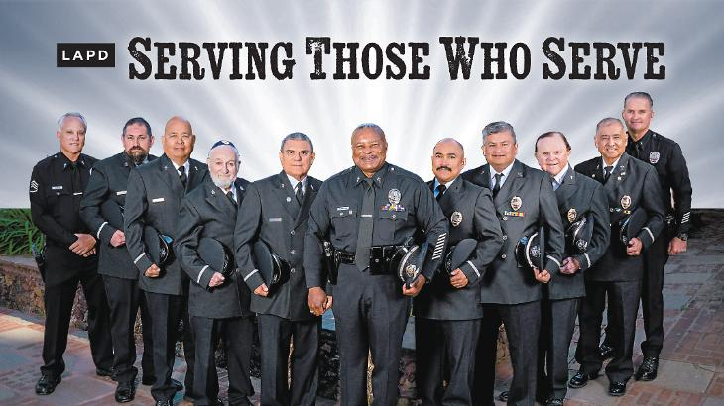LAPD Chaplain Corps. Rabbi Hirsch is fourth from the left.

Servicing the Community in LA
As a rabbi and educator, Hirsch worked quietly, but relentlessly to protect Jewish life. As part of the Los Angeles Crisis Response Team, and later as a chaplain with the LAPD, he became a bridge between faith and civic responsibility. He ensured police understood Jewish holidays, Shabbat mode, and the vulnerability of families walking to synagogue. Increasing crosswalk timing, patrol visibility, simple awareness, his work was driven by partnership.
In the early 2000s, he joined the LAPD Chaplain Corps as a volunteer, serving officers of all faiths. He comforted families after sudden deaths, stood beside officers facing moral injury, and brought quiet presence into moments of unbearable loss. Chaplains trained with psychologists, learned how to speak to grieving parents, attended roll calls, rode along on patrols, and simply showed up, again and again.
For this work, Rabbi Hirsch received numerous honors, including the LAPD’s Saint Michael Award for Chaplain of the Year. But titles never mattered to him.
Even after suffering a stroke in his nineties, he continued visiting his station, attending ceremonies, and bearing witness.
Asked what it takes to be an LAPD chaplain, Rabbi Hirsch offers a deceptively simple answer: “You have to be an erliche person, a person of integrity. Someone who does not judge.”

That quiet definition is his legacy.
Rabbi Israel Hirsch did not measure his life by what he endured, but by how he responded. It is a blueprint for moral courage, how trauma can be transformed into service, how faith becomes responsibility, and how memory demands action. His life conveys a deeply Jewish truth: to remember is not enough. We are responsible for what we do with that memory.
In a fractured world, that responsibility has never mattered more.

Reprinted from the current website of aish.com

The Challenge for the Jew to Work Towards Reaching the Level of Being an “Unpaid Keeper”
From the Teachings of the Lubavitcher Rebbe
Rabbi Menachem Mendel Schneerson, Zt”l
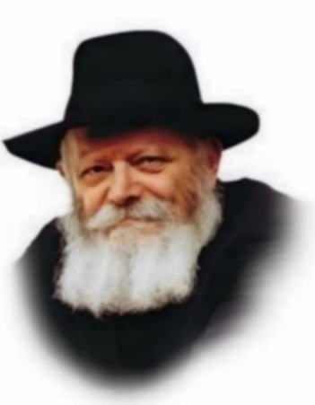

This week's Torah portion, Mishpatim, delineates the four categories of guardianship:
An unpaid keeper - one who serves as trustee for another person's property and does not receive payment; A paid keeper - one who is remunerated for his guardianship; One who "rents" the use of another person's possessions; and a borrower - a person who uses someone else's belongings without paying for the privilege.
The seventeenth-century Sage, known as the "Shaloh," explained that these four categories of guardianship correspond to the four different types of Jews who serve G-d, as every Jew is charged with "guarding" G-d's universe through the observance of Torah and mitzvot (commandments).
The first and highest level of this charge is the "unpaid keeper." This refers to a person whose focus is entirely on guarding the owner's property, without consideration for his own benefit. A person in this category serves G-d with the utmost dedication and devotion, for his sole aim is to serve his Master, unmindful of the reward his actions will bring. Maimonides refers to this type of person as "one who serves G-d out of love...and not because of any other consideration...not in order to accrue benefit, but one who does the true thing because it is true."
The second level of guardianship is the "paid keeper." This person also devotes himself to safeguarding the owner's possessions, but expects to be paid for his labors. This category refers to a Jew who serves G-d with genuine vitality and enthusiasm, at the same time anticipating that he will be rewarded for his observance of Torah and mitzvot.
The third level of guardianship is one who pays for the use of the owner's property. For this person, the enjoyment he derives from the object is his main goal, yet he feels compelled to recompense the owner for granting him the privilege. In the spiritual sense, this refers to a person whose principal desire is to enjoy the pleasures of this world, all the while cognizant that it is G-d Who is allowing him to do so. This type of Jew serves G-d solely out of a sense of obligation and duty.
The lowest level of guardianship is that of the "borrower." This person is only interested in his own gratification, and does not even feel the need to compensate the one who has lent him the object. In terms of our G-dly service, this refers to one who delights in the pleasures of this world without even thinking of "paying" G-d back for His beneficence.
Yet even the "borrower" is considered a guardian, for he too observes Torah and mitzvot, albeit without perceiving the connection between his service of G-d and the blessing he receives from Above.
This person is convinced that all of the goodness and bounty in his life has been granted to him simply because he is deserving!
What is the point in a mitzva done for personal considerations?
Our Sages explain: "A person should always busy himself in the observance of Torah and mitzvot, even when it is not for its own sake." For we are assured that from the wrong considerations, one will come to observe for the right reasons. Every Jew is promised that ultimately, he will perfect his service of G-d, achieving the level of the "unpaid keeper."

Reprinted from the Parashat Mishpatim 2003/5763 edition of L’Chaim, a publication of the Lubavitch Youth Organization. Adapted from Likutei Sichot of the Rebbe, Vol. 31

Thoughts that Count
for Parsha Mishpatim

Six years shall he serve, and in the seventh he shall go free. (Ex. 21:2)
"Six years" symbolizes the six thousand years of the world's existence. "Shall he serve" refers to our mission to learn Torah and perform the commandments. "In the seventh" refers to the seventh millennium, when "he shall go free" - when the Messianic Era shall reign on earth and G-dliness will no longer be hidden but revealed. (The Lubavitcher Rebbe)

For all manner of transgression...of which he can say, "this is it" (Ex. 22:80)
Pride is the root of all transgression. The essence of sin is when a person says of himself - "this is it" - "I am the most important thing in the whole world!" (Rabbi Yisrael of Modzitz)

If you lend money - kesef. (Ex. 22:24)
The Tzemach Tzedek, the third Chabad-Lubavitch Rebbe, explained that the Hebrew word for "money" - "kesef" - comes from the root word meaning "longing and yearning." The soul, he explained, always yearns to go upward, attaining higher and higher levels of spirituality. "If you lend money" - G-d "lends" the eternal soul to each of us for a certain period of time, to dwell in a physical body in this world. It is up to the individual to utilize that loan to the fullest, taking advantage of every day that is granted on earth. (Hayom Yom)

And He will bless your bread and your water, and I will remove sickness from your midst (Exodus 23:25)
Most illnesses are caused either by food that is ingested, or from an intensification of internal forces within the body. G-d therefore promised to send His blessing in both of these areas, blessing the food one eats - "your bread and water" - and "removing sickness from your midst" - making sure that illness does not come from within. (Kli Yakar)

You shall not afflict any widow or orphan (Exodus 22:21)
Whenever Rabbi Levi Yitzchak of Berditchev reached this verse he would cry out. "Master of the Universe! You instructed us in Your holy Torah to be kind to widows and orphans, and yet we are like orphans in this bitter exile! You must therefore take us out of this exile at once!"
And He will bless your bread and your water, and I will remove sickness from your midst (Exodus 23:25)
Most illnesses are caused either by food that is ingested, or from an intensification of internal forces within the body. G-d therefore promised to send His blessing in both of these areas, blessing the food one eats - "your bread and water" - and "removing sickness from your midst" - making sure that illness does not come from within. (Kli Yakar)

Reprinted from the Parashat Mishpatim 2003/5763 edition of L’Chaim, a publication of the Lubavitch Youth Organization.

Why Did Chacham Ovadia Stop Serving as Sandek for Twins?


Rav Yitzchak Yosef
In his weekly shiur last night at the Yazdim Shul, former Sephardic Chief Rabbi Rav Yitzchak Yosef shared a personal and little-known family story explaining why his father, Chacham Ovadia Yosef zt”l, made a lifelong decision to decline serving as sandek at the bris of twins.
Rav Yosef revealed that the decision stemmed from a traumatic incident many years earlier. According to his account, his father once served as sandek for twin boys. Several weeks later, one of the infants tragically passed away. The event left a profound mark on Rav Ovadia, who feared that serving as sandek for two children in succession might involve ayin hara.

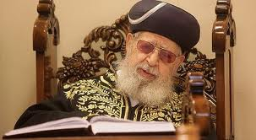
Rav Ovadia Yosef

“After that,” Rav Yitzchak Yosef related, “my father was afraid. He said perhaps it was ayin hara, that one person was sandek for two children one after the other.” From that point on, whenever Rav Ovadia was invited to such a bris, he firmly declined to serve as sandek for both infants, saying, “I will sit for one—bring someone else for the second.” Rav Yosef added that his father carried genuine pain over the episode and consistently refused thereafter.
During the same shiur, Rav Yosef offered practical guidance regarding the laws and customs of bris milah. He emphasized the importance of choosing a sandek who is a talmid chacham, while noting that the primary requirement for the mohel is professional competence. “A sandek, it is important to choose a talmid chochom,” he said. “As for the mohel, what matters most is that he knows how to perform the milah. If he is also a talmid chochom and available, that is preferable, but otherwise one may choose a skilled mohel.”
He concluded with sharp criticism of the practice of postponing a bris milah until the afternoon hours. Citing the ruling of the Or Zarua, he stressed that delaying the milah is considered a ביזוי מצוה, a degradation of the mitzvah. “Why do a bris at two in the afternoon?” he asked pointedly. “A person waits years, davens, perhaps has many daughters and finally merits a son—and then he delays the bris until the afternoon?” He urged parents to perform the bris before midday whenever possible, reiterating that delaying it unnecessarily diminishes the honor of the mitzvah.

Reprinted from the Matzav.com website.
Stranded in Extreme Winter Storm, Travelers and Communities Find Warmth at Chabad
By Motti Wilhelm


As a historic winter storm affected 40 states, Chabad of Nashville was just one of the centers that stepped up to support their community.

A large swath of the United States ground to a halt at the start of the week as a historic winter storm blanketed more than 40 states with snow, ice, and subfreezing temperatures.
The storm triggered widespread power outages affecting hundreds of thousands, prompting states of emergency to be declared in 24 states, and leading to nearly 20,000 flight cancellations. Countless individuals found themselves stranded, either unable to return home or stuck inside without adequate heat, food, or shelter.
Across the country, Chabad-Lubavitch rabbis and rebbetzins sprang into action, setting aside their regular schedules or their own snow shovels to assist those in need.
In Minnesota, no stranger to heavy snow and punishing winter weather, Rabbi Mendel Feller, director of the Upper Midwest Merkos–Lubavitch House, received word that a Delta flight from Tel Aviv to New York’s JFK Airport had been diverted to Minneapolis–Saint Paul International Airport. More than 300 passengers would now be stranded far from home, in unfamiliar surroundings, and without knowing how to access kosher food.
Sunday was already a full day for Rabbi Feller and his wife, Nechama Dina, who co-directs Lubavitch House with him. A sheva brachot celebration for some 30 guests was scheduled to take place in their home that evening, and Mrs. Feller was set to travel out of town the next day. Still, Rabbi Feller immediately began arranging a hot meal and even snacks for the travelers.
“Around 1:30 p.m., I got a call from my father telling me about the diverted flight,” said Rabbi Tzemach Feller, who directs Chabad of Macalester-Groveland in St. Paul together with his wife, Mushky. “He said there were 300 Jewish passengers who were going to need food and asked if I could come to Lubavitch House to help. Of course, I said yes.”
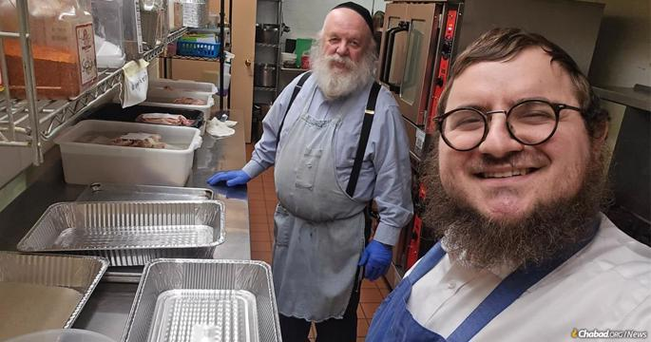
Anshel Introlegator and Rabbi Tzemach Feller joined the Lubavitch House team to help serve the 300 Jewish passengers stranded in Minneapolis.
In the Lubavitch House commercial kitchen, he was joined by Anshel Introlegator, a chef who regularly volunteers there. Anshel, along with his wife, Yetta, and their daughter, had also been contacted by Rabbi Mendel Feller and together they got to work.
“Cooking is something I love, and helping another Jew is always a privilege,” Anshel said. “I came right over.”
They emptied the community center’s freezer, preparing chicken, pasta and rice for all 300 travelers. At the same time, they coordinated with Kosher Spot, the local kosher supermarket, to arrange a special delivery of cold cuts, bread, bagels, instant soups, and packaged pastries to distribute.
While his son and the Introlegators cooked up a storm, Rabbi Feller sent a message to popular travel forums so that even before the Delta flight landed, the stranded passengers would have peace of mind. He shared that Chabad would be providing a hot supper and additional food provisions, along with addresses and information for kosher stores and local synagogues for evening prayers.
The volunteers spent about six hours at Chabad preparing the food, finishing up around 8 p.m., exhausted but grateful for the opportunity to help others.

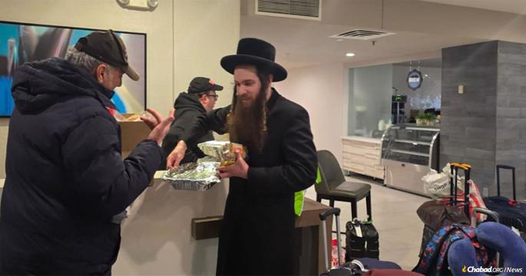
Jewish people of all backgrounds rode out the storm together at Chabad.

When the travelers arrived, the Fellers were joined by more volunteers who delivered the food to the six hotels where the stranded passengers had been placed by the airline.
“Thank you for arranging dinner last night,” one traveler wrote to the Fellers the next morning as the group finally continued on to New York. “After such a long day of travel, having warm, home-cooked food meant everything. We felt overwhelmed and stranded in an unfamiliar place without easy access to food or transportation, and your welcome was truly heartwarming.”
“The Rebbe [Rabbi Menachem M. Schneerson, of righteous memory,] taught us that our mission is to care for our fellow—materially as well as spiritually,” said Rabbi Tzemach Feller. “It was beautiful to see how the community came together to be there for perfect strangers; volunteers spending their day off cooking and delivering meals.”

In Nashville Blackout, Community Rises
A few hundred miles to the south, in Nashville, Tenn., the storm caused disruptions not only for travelers but also for locals. Ice weighing down trees and power lines left nearly 300,000 people without electricity and was linked to at least five weather-related fatalities. As of Wednesday, more than 100,000 Tennesseans remained without power.
Rabbi Yitzchok and Esther Tiechtel, who co-direct Chabad of Nashville, immediately began checking in on community members. With a backup generator keeping the Chabad House warm, they opened their doors, offering hot meals, shelter, and a place to sleep to anyone in need.
One of those residents was Eileen Korby, who found herself sitting in a dark, unheated home as the storm wore on.
“I got a call from Rabbi Tiechtel asking if I needed food or a hot meal,” she said. “Most stoves in Nashville are electric, so without power there’s no way to cook. I couldn’t make it to Chabad in those conditions, but he told me someone could bring it to my house.”
Although she initially declined what she described as their “considerate and thoughtful” offer, the next day, once she was able to use her car, she drove to the Chabad center and received a generous supply of food.
“I’m still eating what he gave me on Wednesday,” she said with a smile. “I must note that I only moved here at the end of December. I’m not a longtime member. But Rabbi Tiechtel remembered me and made sure I had what I needed.”
Ice weighing down trees and power lines caused the lengthy blackout.
There was also Peter Allingham and his wife, an elderly couple, who were stuck in their home for three days without heat or electricity; Chabad provided them with meals and reassurance. Raff Hezami, a father of four with two young children, also endured days without heat. He brought his family to Chabad of Nashville, where they were welcomed with hot food, and a safe place to rest. Dozens of others received similar assistance.
“In moments like these, leadership means showing up with heart and soul,” said Rabbi Tiechtel. “Every person is created with purpose and worth. Our responsibility is to care for each individual with love and warmth, especially when people feel afraid or forgotten. No one should ever feel alone.”
While storm relief may not be part of their regular programming, the rabbis see their efforts as something that goes straight to the heart of their mission.
As Rabbi Mendel Feller explained: “In the first Chassidic discourse the Rebbe delivered on 10 Shevat 1951, he recounted how the Alter Rebbe, Rabbi Shneur Zalman of Liadi, the founder of the Chabad movement, interrupted his Yom Kippur prayers to visit a woman who had just given birth and was in dire straits. On the holiest day of the year, he lit a fire and prepared food for her, saving her life. As we approach the 75th anniversary of that historic discourse, which is being marked this week, it felt fitting to pause our own activities and provide food to fellow Jews in their time of need.
“This story captures the essence of the Rebbe’s leadership,” he continued. “No matter how lofty one’s spiritual aspirations may be—and, as the Rebbe remarked on another occasion, none of us can begin to compare our aspirations to the sanctity of the Alter Rebbe’s Yom Kippur prayers—we are reminded that the wellbeing of our brothers and sisters must always remain at the forefront.”

******************************************************************
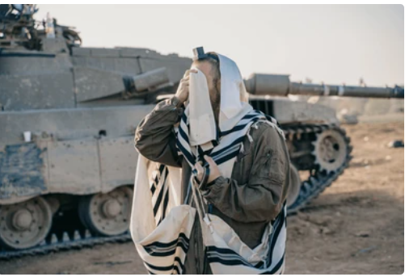
Photo of Israeli soldier praying during a break in the recent War at Gaza

